

1. In this lesson, we will talk about distributed shared memory systems for DSMs. These are an an example of applications that perform certain distributed state management operations. Now, in this lesson, a lot of what we will talk about will be in the context of memory management. Still the methods that we will discuss will apply to other types of distributed applications. Specifically, we will present certain design alternatives, with respect to DSM systems. And we will discuss the trade offs that are associated with those decisions. In addition, we will discuss several important consistency models that are commonly used in systems that manage distributed and shared state

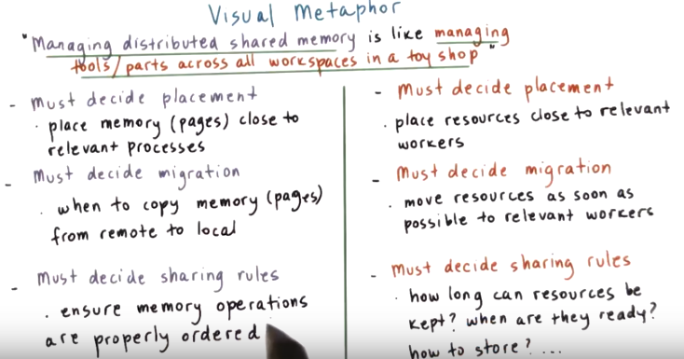

2. In this lesson we will be talking about another distributed service, specifically distributed shared memory. Now recall that in a previous lesson on memory management, we made a visual analogy between the memory contents of a process and the parts used by workers sharing a single work space. Holding off of that analogy, managing distributed shared memory is like managing the toy parts or even the tools across all the work spaces in a toy shop. As you can see from this image, it is very similar to the one that we used for the distributed file systems because we want to show that there are multiple distributive nodes that are working together towards providing a service. The service that's provided is the sharing of the tools and the toy parts among workers that are working on multiple such work benches. So you imagine even in a single location like this, there will be multiple such workbenches with multiple workers using certain toys and toy parts and tools and this is what we want to facilitate, the sharing of those tools and parts. For the management of tools and toy parts in a toy shop there are three major decisions that must be made. The first one is how are we going to place all these resources in the distributed environment. Next we must decide how and when to move tools around the different shops or the different work benches in those shops, and finally we must establish some rules how those toy parts and tools will be shared. For instance, regarding placement we would probably decide to place those resources close to the workers that are currently needing them to perform their task. When a worker on one work bench is done with a particular resource and another worker on another workbench or potentially in another location needs that resource we should move it as soon as possible. And finally we must have policies on how long can a worker keep a tool on their desk or when and how workers should let others know that a tool or a toy part is ready and is available for use by others. Or for instance when should the tools or the toy parts be placed into a storage facility that others can access as well. For managing distributed shared memory, we must make similar types of decisions however clearly the details are going to be very different. For instance, when deciding placement, we should typically place the contents of memory or the contents of a page in a physical memory that's close to a particular process. This would be the process that either created that content and or will be using that content. When a process needs access to memory that's stored in a page param on a remote node, we should come up with some policy how to migrate that content to the local node. For instance, we can copy that content that memory page from the remote to the local physical memory. Since the memory page may be concurrently accessed by multiple processes, and in addition since we may have multiple copies of that page in different locations in the system, it's important to establish some rules how the different operations are ordered. How they're propagated across the different copies, so that there is a consistent view of the entire memory.

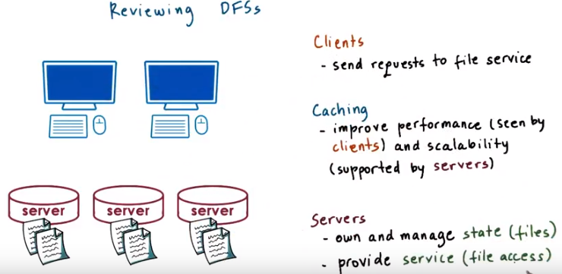
由上圖知, state即 file. 下段也會用到這個.

3. In the previous lesson, we talked about Distributive File Systems. We said that Distributive File Systems were an example of a distributive service where the state, the files, were stored on some set of nodes, the file servers. And then the file servers were accessed by many distributive nodes clients. All of the file access operations open, read, write on these files. Where then service that was provided by these servers, and that these client nodes were requesting from them. Our primary focus of the Distributed File System lesson was the caching mechanisms. These are useful so that server data is cached on the clients. And this is a mechanism that improves the performance that's seen by the clients. The clients can now access these files more quickly. Caching is also a mechanism that enhances the scalability of the distributed file system overall of the servers. Because some of the operations are now performed by the clients, the servers don't have to perform every single access and therefore they can scale to support a larger number of clients and serve larger number of files potentially. What we didn't talk about is, what happens in the situation when there are multiple file servers, and how do they control and coordinate the access of shared state, of shared files, among them. We also didn't talk about situations in which all of the nodes in the systems were both servers, storing files and allowing access to those files, as well as clients sending request to other nodes in the system. In such a scenario there really isn't a clear distinction between client nodes and server nodes. Every single one of the nodes would be performing all of the services. In this is lesson distributed shared memory, we will talk about these kinds of scenarios, the distributed applications, where all the nodes in the distributed environment are both the servers that provide the state and provide the access to that state and also issue requests to other nodes in the system to their peers. So, perform some of the client functionality that we saw before.

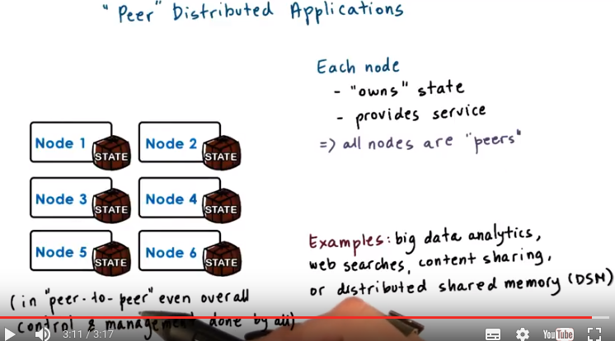
4. Let's talk now about these cases where there isn't a clear distinction between servers and clients. For instance if you look at all of the big data applications that we hear about today, the state of the application is distributed and stored across all nodes. The processors on these nodes run certain applications such as the analytics codes, the mining codes, searching for patterns or searching in order to answer your Google web search request or some other applications. And they access the state that's distributed across all the other nodes in the system. The key about these applications is that every node in the systems owns some portion of the state. By own here we mean that there is some state that's locally stored in a particular node or that's generated by computation that's running on that node. So the overall application state is the union of all of these pieces that are present on every one node. It's as if all the nodes in the system are peers. They all require accesses to the state anywhere in the system and they all provide access to their local storage state to any of their other peers in the system. For instance, think about the large web search applications, like Google. The state in that application, which is the information about every single webpage in the world, is stored on many machines. And at the same time, it's also processed on all of them. Whenever you type in a web search, it may get processed on a different processor in this distributed system, but the state that's required for that web search, regardless in which processor it hits, may be somewhere on some of the other nodes. Applications like Facebook and YouTube, also have state that includes billions of images and videos. In these images and videos are a process to detect certain objects to transform them into different formats and sizes. So there's some computation that's performed on that distributed content. The code that performs these processing operations, these transformations, trans-coding of the videos or the images, may run on different nodes in the system, but may potentially need to access state that's distributed on other nodes. These applications are examples of applications where every node is responsible for managing the locally stored state and providing access to the locally stored state. But also at the same times accessing the state that's stored by the remaining nodes in the system. The reason I'm putting the term peer here in quotation marks, and not using a popular term that you may have heard of, peer-to-peer systems, is that in these kinds of distributed applications it is still possible that there will be some number of designated nodes that will perform some overall management and configuration tasks for the entire system. So, there's some portion of control plan tasks or management plan tasks that are performed by some more centralized designated set of nodes that's not evenly distributed among all nodes. In a peer-to-peer system, even the overall control and management of this system would be done by all.

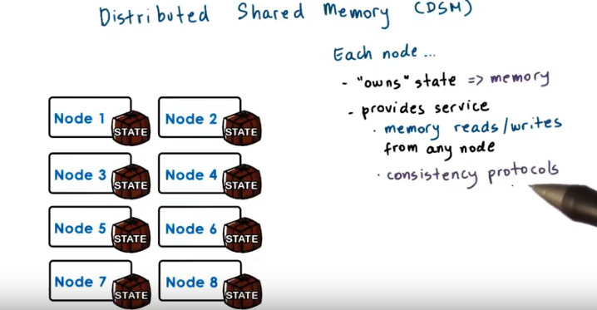
5. A concrete example of this type of applications is distributed shared memory. Distributed shared memory is a service that manages the memory across multiple nodes so that applications that are running on top will have an illusion that they're running on a shared memory machine, like a SMP processor. Each note in the system owns some portion of the physical memory, so owns some state, and it also provides the operations in that state, the reads and writes. They may be originating from any of the other notes in the system. Also, each note has to be involved in some consistency protocol, so as to make sure that the shared accesses to the state have meaningful semantics. For instance, when nodes read and write shared memory locations, these reads and writes have to be ordered and observed by the remaining nodes in the system in some meaningful way, ideally, in the exact same way that they would have been perceived if this was indeed, a shared memory machine. In this lesson, using distributed shared memory as an example, we will illustrate some of the issues that come up with distributed state management, beyond just caching, that we already saw in the distributed file system lecture. We will also discuss some meaningful consistency protocols that are useful in these kinds of scenarios.

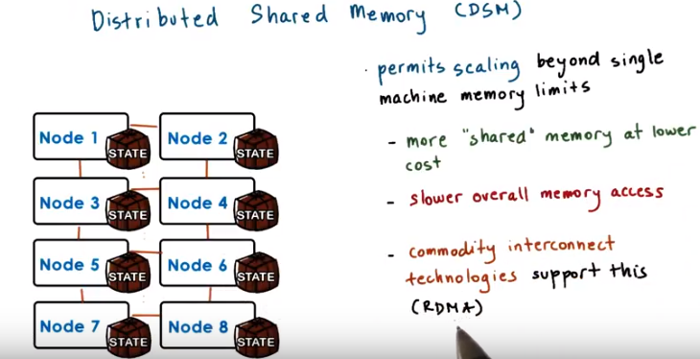
RDMA: Remote Direct Memory Access

Distributed shared memory mechanisms are important to study because they permit scaling beyond the limitations of how much memory we can include in a single machine. If you have a multi-thread application or in general an application that was developed with the expectation of shared memory underneath and all of the sudden you need to support work loads that require more state, you have to add more memory to that system. Now, if you look at how the cost of computer systems is affected by the amount of memory they're configured with, you will see that beyond a certain limit, the cost starts increasing rapidly, and machines with very large amounts of memory can be in the order of half million dollar range. Instead with distributed shared memory we can simply add additional nodes and achieve shared memory at a much lower cost. Yes, access in remote memory will be slower than access in the local memory. However, if you're smart about how data is placed in the first place in the system, how it's migrated across the different nodes, and what kind of sharing semantics are enforced whenever something gets updated, we may hide those access difference from the applications so we may not even perceive there is any kind of slowdown because they're executing and distributed in that environment. One goal of this lecture is to teach you what are some of the opportunities to hide these access differences. Distributed shared memory is becoming more relevant today, because commodity interconnect technologies offer really low latency among nodes in a system. For instance, these are interconnect technologies that connect the servers in a data center and they offer these RDMA based interfaces, where RDMA stands for Remote Direct Memory Access. That provide a really low latency when accessing the remote memories and that really helps address this particular challenge, the fact that accessing remote memory is slower. Using these advanced interconnection technologies makes these remote accesses significantly better than what they were before such interconnection opportunities existed. Because of that, distributed shared memory based solutions are becoming more sustainable.

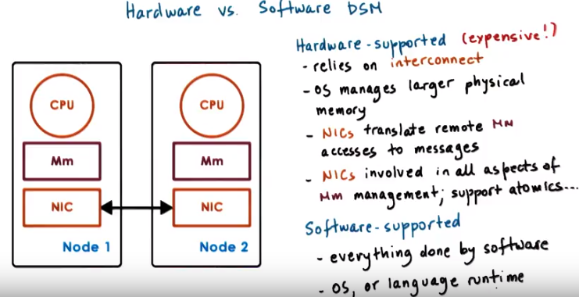
NIC: network interconnect card

6. Distributed shared memory can be supported either in hardware, or by software. The key component of the hardware supported distributed shared memories, is that they rely on some high end interconnect. The operating system running on each individual node, is under the impression that it has much larger physical memory, constituting memory that spans multiple memory nodes, multiple physical nodes in the system. So, the OS is allowed to establish virtual to physical memory mappings that correspond to memory locations that are in other nodes. The memory accesses that reference memory locations that don't correspond to the local physical memory are then passed to the network interconnect card and this is a NIC that corresponds to this advanced high end interconnect technology. So, these NICs know how to translate that memory operation, into an actual message that gets sent to the correct remote node, the correct NIC. The NICs in these nodes will participate in al aspects that are necessary to deal with memory accesses, and management of memory consistency and we'll also support certain atomic operations just like the atomics that we saw in shared memory systems. Now while it's very convenient to rely on the hardware to do everything, this type of hardware is typically very expensive and it's used only for the ultra high end machines or for the super computing platforms. Instead, distributed shared memory systems can be realized in software. Here the software would have to detect which memory accesses are local versus remote to create and send those messages to the appropriate node, whenever that's what, what's necessary. The software would also have to accept messages from other nodes and perform the specific memory operations for them and also be involved in all of the aspects of memory sharing and consistency support. This can be done at the level of the operating system or it can be done with support of a programming language and the runtime product programming language.

7. For a quiz, I would like you to take a look at a paper, Distributed Shared Memory: Concepts and Systems. This was an older survey paper that describes several implementations of distributed shared memory systems, and compares them along multiple dimensions that we will discuss in this lesson. The specific question you need to answer is the following. According to the paper Distributed Shared Memory: Concepts and Systems, what is a common task that's implemented in software, in hybrid, hardware plus software, DSH implementations? The choices are prefetch pages, address translation, or triggering invalidations. As a hint go straight to page 76 of the original paper PDF that's linked in the instructor's notes and start reading at the hybrid DSM implementations heading. So you don't have to read the entire paper, but I do encourage you to do so if you have a chance or at least to look at it in a little bit more detail than just jumping to this hybrid DSM implementation section.

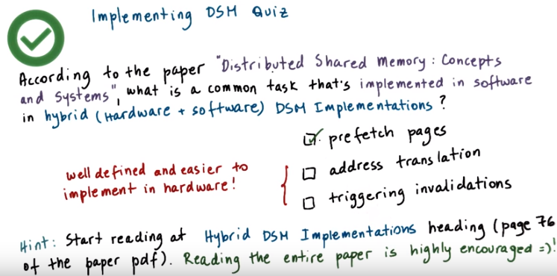
8. If you read through the hybrid DSM implementation section you will see that it mentions several examples of DSM systems and specifically describes what are the software tasks that those hybrid implementations support. And for every one of those examples prefetching is listed as one of the software tasks. It makes sense that prefetching is a good task to be implemented in software. Whether or not prefetching is useful is going to depend on a particular application, on the kind of access pattern that it exhibits. At the same time, address translation or triggering invalidations are more concretely defined. And it's easier to implement them with hardware support. For these reasons, prefetching pages is the only correct answer to this question.

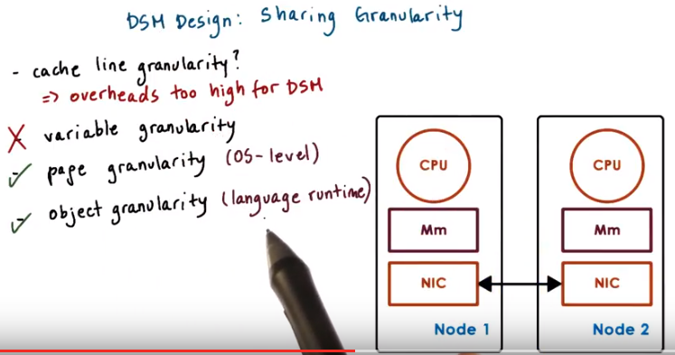
9. Several design points are important to consider when designing a distributed shared memory system. First is the granularity of sharing. In SMP systems, the granularity of sharing is a cache line. The hardware tracks concurrent memory accesses at the granularity of a single cache line. And triggers all the necessary coherence actions like invalidations, if it detects that a cache line has been modified, if that cache line has been shared with other caches. For distributed systems, adopting a solution where every single 'cache line sized write message' is being sent to nodes over a network will potentially be too expensive. And it will be hard to justify the use of such system, the performance slowdown will be significant, and likely, it won't be very useful. Instead, distributed shared memory designs look at larger granularities of sharing. Some options include variables, or pages of virtual memory, or entire objects as defined by some higher level programming language. Variables are meaningful from the programmer's perspective so potentially DSM solutions can benefit. Because the programmer can provide some explicit support to tell the distributed shared memory system how and when individual variables should be shared. However, this is still potentially too fine granularity. We have a lot of variables that just few bytes long, like integers. And in those settings, the DSM system would still have very high overheads. Using something larger, like an entire page of content or a larger object, that begins to make more sense. If the distributed shared memory system is to be integrated at the operating system level, the operating system doesn't understand objects. The only thing that it understands is pages of virtual memory. And then, the OS tries to map those pages of virtual memory to the underlying physical page frames. So at the operating system level, it makes sense to integrate some page-based DSM solutions. The OS would track when pages are modified, and then, it would trigger all of the necessary messages that need to be exchanged with remote nodes on page modification. Pages are larger. We set a common page sizes for kilobytes in many environments. And so it is possible to then amortize the cost of the remote access for these larger granularities. With some help from the compiler, application level objects can be laid out on different pages, and then we can fully just rely on the page base operating system level mechanism. Or, we can have a distributed shared memory solution that's actually supported by the programming language and the runtime, where the runtime understands which objects are local versus remote objects. And for those objects that are remote ones, the run-time will generate all of the necessary communications with remote nodes and all the necessary operations to provide distributed shared memory. In that case, the operating system doesn't really need to know anything about the DSM solution. So, the benefit of that is that the operating system doesn't have to be modified in this case, but this is clearly going to be a less general solution. It will be applicable only for those languages for which there is such a DSM support.

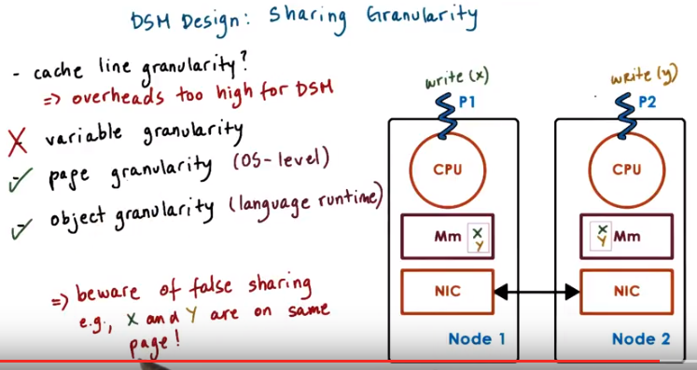
Once we start increasing the granularity of sharing, one important problem that everyone has to be aware of is what's called false sharing. Consider a page or even a higher level object that internally has two variables, x and y. A process in one node is exclusively accessing and modifying x. It doesn't completely care about anything that's stored in the variable y. Similarly, a process on another node is exclusively concerned with y. And it has no reference whatsoever, to the other variable, x. Now when x and y are shared on the same page, as in this example here, the distributed shared memory system, when it's using these larger granularities, that's the only thing that it understands. So it understands a shared page. So it will interpret these two write accesses (P1 write x, P2 write y) to that shared page as some indication of concurrent accesses to the same location. And it will trigger any necessary coherence operations, invalidations, updates, or any of the other overheads that are associated with maintaining consistency among these two copies. Such coherence overheads won't benefit anyone. P1 doesn't care what happened to y, and also, P2 doesn't care what happened to x. In order to avoid these kinds of situations, the programmer must be careful how data is allocated and laid out on pages, or how it's grouped in higher level objects. Or the other alternative is to rely on some smart compiler that will be able to understand what is really shared state. And then allocate it within a page or within an object, versus what is something that will trigger these false sharing situations.

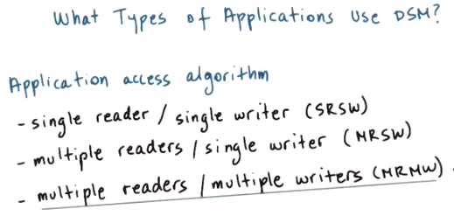
10. Another important design point in distributed shared memory systems is to understand what are the types of access algorithms that need to be supported on top of that DSM solution? In other words, to understand what are the kinds of applications that will be running on top of the DSM layer. The simplest example is single reader/single writer. For these kinds of applications, the main role of the DSM layer is to provide additional memory, to provide the application with the ability to access remote memory. In this case, there really aren't any consistency or sharing related challenges that need to be supported at the DSM layer. The more complex examples are of an application support either multiple readers and single writer, or both multiple readers and multiple writers. In those cases, it's not just about how to read or write to the correct physical memory location in the distributed system, but it's also about how to make sure that the reads return the correctly written, the most recently written value of a particular memory location, and also that all of the writes that are performed are correctly ordered. This is necessary so as to present the consistent view of the distributed state of the distributed shared memory to all of the nodes in the system. Multiple reader, single writer, is a special, simpler case of the multiple reader, multiple writer problem. And so, in our discussion in this lesson, we will focus on DSM support for multiple readers, multiple writers.

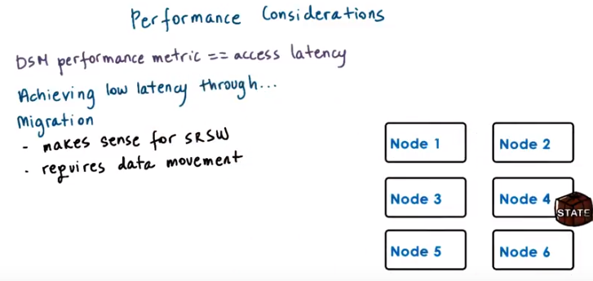
11. For a distributive shared memory solution to be useful, it must provide good performance to applications. If we think about the core service that's provided by distributive shared memory systems, accessing memory locations, then it's obvious that the performance metric that's relevant for DSM systems is what is the latency with which processes running on any one of these nodes can perform such remote memory accesses. Clearly, accessing local memory is faster than remote memory. So, what can we do in order to maximize the number of cases where local memory's accessed versus remote? One way to maximize the number of local accesses and achieve low latency is to use a technique called migration. Whenever a process on another node needs to access remote state, we literally copy that state over to the other node. This makes sense for situations where we have a single reader, single writer. Since only one node at a time will be accessing this state, so it does make sense to move the state over to where that single entity is. However, this requires moving the data, copying the data over to the remote node, and that incurs some overheads. So even for these single reader, single writer cases, we should be careful when we trigger these types of mechanisms because if it's only going to be a single access that will be performed in this other location, then migrating, copying over the entire state over to node four, it won't be amortized. We won't get much in terms of low latency improvements if we have to copy all this data just for a single read or write access. For the more general case, however, when there are multiple readers and multiple writers, migrating the state all over the place doesn't make any sense since it needs to be accessed by multiple nodes at the same time.

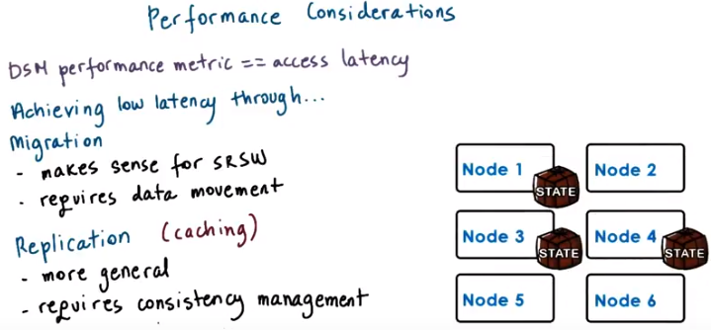
So, a mechanism such as replication where the state is copied on multiple nodes, potentially on all nodes, is a more general mechanism. Use of caching techniques, which create a copy of the state on each node where the state was accessed, can lead to some similar behavior as what's seen with replication. One problem with this is that it requires consistency management. Now this state will be accessed concurrently on multiple nodes. And we have to make sure we coordinate those operations, as we said, to order all of the writes, propagate the most recent write operation to wherever or whomever is performing the next read operation. This is some overhead. One way to control the overhead is to perhaps limit the number of replicas, the number of copies that can exist in this system at any given point of time since the consistency management has overhead that's proportional with the number of copies that need to be maintained consistently.

12. Let's take a quiz about DSM performance. The question is: if access latency as a performance metric is a primary concern, which of the following techniques would be best suited in your DSM design? The choices are: migration, caching, or replication. And you should check all that apply.

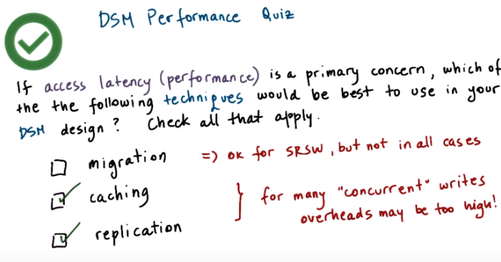
13. Before answering we should consider the access algorithm, like single reader, single writer, multiple reader, multiple writer. If we only have single reader, single writer then migration is okay, but it's not good in all of the other cases. In a more general problem that has multiple readers and multiple writers, with migration, pages would have to be flipped back and forth between nodes, and so migration is really not a good technique. Migration can in fact lead to an increase in latencies for the more general problem. If we look at the other two options, caching brings the data on the node, where it's accessed, and therefore it will definitely improve the latency of the subsequent operations to that data. And similarly replication in general will create copies of the data that are potentially closer to where the data is accessed and therefore can leads to improvements in latency. Now whenever there are multiple concurrent writes in the system, caching and replication can also lead to high overheads. If you remember in the distributed file system lecture, we mentioned that in the sprite file system, whenever it was detected that there are multiple concurrent writers, caching or in general the presence of multiple copies of the particular state, a file in that case, was disabled so as not to have to deal with multiple invalidations or loss of consistency.

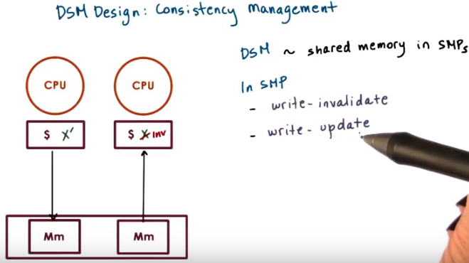
SMPs: shared memory multi processors

14. Once we've permitted multiple copies of the same data page or object to be stored in multiple, locations, the question of maintaining consistency comes up. Since distributed shared memory is intended to behave in a similar manner to shared memory in shared memory multi processors, let's remind ourselves what we did in shared memory multi processors, for consistency management. In the lesson on synchronization, we explained that in shared memory multiprocessors consistency is managed using two mechanisms, a write-invalidate or write-update. With write-invalidate, whenever the content particular memory location that's cached to multiple caches is changes on one CPU in one cache. Back via the coherence mechanisms will be propagated to other caches and in the case of write and validate the other caches will invalidate their cache content.

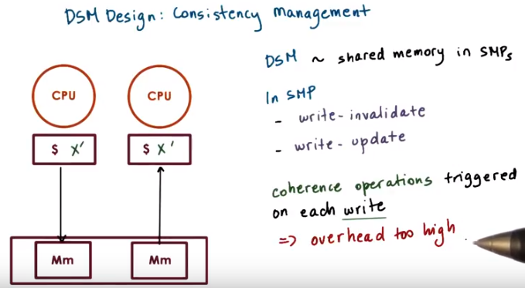
Or in the event that we have a write update coherence mechanism, then the other caches will receive the newly updated copy of that particular memory location. These necessary coherence operations are triggered by the shared memory support in the hardware on every single write operation. And the overhead of supporting that in the distributed shared memory system where the latencies and the costs of performing distributed communication are too high is not going to be justifiable. For these reasons for distributed shared memory, we'll look at coherence operations that are more similar to what we discussed in the distributed file systems lecture.

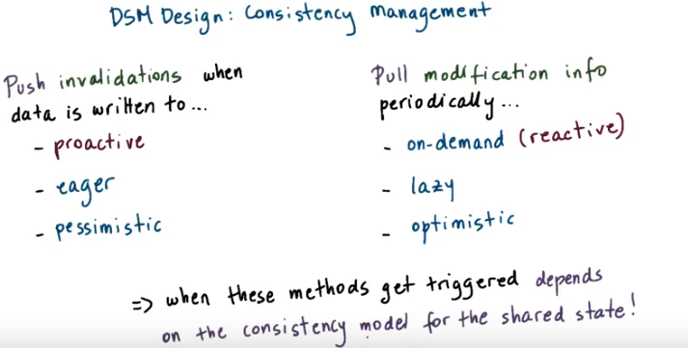

proactive: 積極主動的
reactive: 反應的
注意左邊是pessimistic, 而不是optimistic

One option is to push (不是push in a queue的意思, 而是github中push的意思, 跟pull相對) invalidation messages when a data item is written to. This is similar to the server-based approach that we talked about in the distributed files systems lesson. But remember that the state management in DSM systems is done by all peers. We don't have clients and servers, per se in this case. The other option is for the nodes to pull information about any modified state from one or more of the other nodes in the system. This can be done either periodically or purely on demand whenever some process needs to access that state locally, it will check with others to see whether it's been modified or not. I intentionally chose the terms push and pull since these are commonly used to distinguish between this more proactive versus this more reactive approach to accomplishing some tasks. In this case, maintaining the consistency among two notes in the distributed system. Another set of terms associated with these types of actions is eager versus lazy. The push based method is eager since it forces propagation of information immediately, eagerly. in contrast, the pull method is lazy, since it lazily gets the information when it's convenient or when it becomes absolutely necessary. And yet, another set of terms to distinguish between these two types of approaches is pessimistic versus optimistic. This push based eager method is pessimistic in that it expects the worst. They expect that the modified state will be needed at other places at other nodes immediately. And so with these methods, nodes are in a rush to notify others that a modification happened. In contrast, these optimistic methods hope for the best. Here the hope is that the modified state wouldn't be needed elsewhere anytime soon. And that there is plenty of opportunity to accumulate information regarding modifications before anyone has to pay for the cost of sending an invalidation or moving data across the distributed system. Regardless of whether we talk about the push versus pull based methods. When exactly they get triggered, whether its after every single data has been modified or whether its with a period of five seconds or ten seconds or one millisecond, or in some other manner, that really is going to depend on the consistency model for the shared state and we will discuss what are the options for consistency models a little bit later in this lecture.

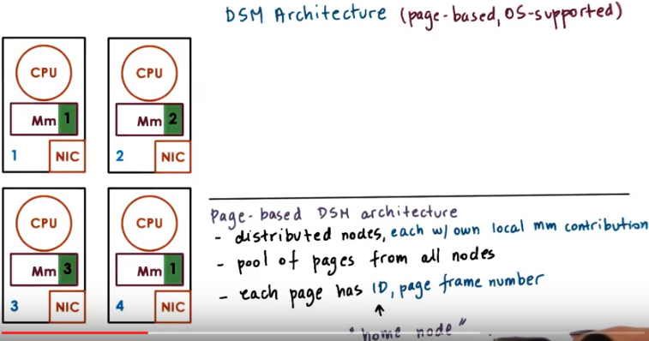
上圖中的 (page-based, OS-supported) 意思不是有page-based和OS-supported這兩種DSM architecture, 而是只有page-based這一種DSM architecture, 且它是OS-supported的.

15. Based on what we described so far, let's take a look at how a distributed shared memory system can be designed. This type of system consists of a number of nodes, each with their own physical memory. Everyone of the nodes may contribute towards the distributed shared memory system, only a portion of their physical memory, or it can contribute all of it. Let's assume here, that only a portion of the physical memory, is contributed towards the DSM service and can explicitly be addressed. Whereas the rest of the memory is used either for caches or for replication or for some metadata that's needed for the DSM layer. The pool of memory regions, the memory pages that every single one of these nodes contributes, forms the global shared memory that's available for applications running in the system. Every address in this memory pool will be uniquely identified based on the identifier for the node where it's, residing, as well of the page frame number of that particular physical memory location. The node where our page is located is typically referred to as the home node of that page.

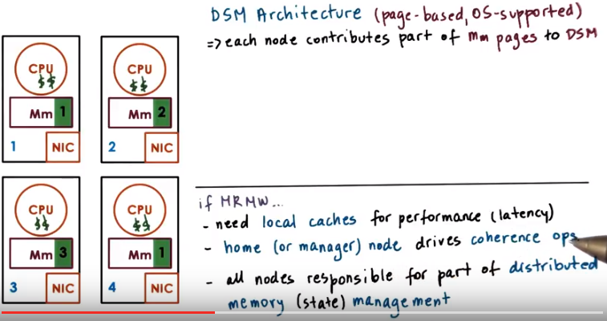
Now let's say, we're trying to solve the most general case where the system is supposed to support applications that have multiple reader, multiple writer requirements. For that reason, in order for the system to deliver acceptable performance, and achieve low latency with which the memory accesses are performed, the DSM layer will incorporate use of caching. Pages will be cached on the nodes where they are accessed, and for a state that's cached, for memory pages that are stored on these remote nodes. The home node, or the manager node, will be responsible for driving all of the coherence related operations, so, it will maintain state, that's necessary to track the number of readers, the writers, whatever cache has been modified, et cetera. In this way, all of the notes in the system are responsible for some portion of the management operations for that distributed memory. The information that's maintained at the home, or the manager node is similar to the kind of information that we saw that the servers have to maintain in the distributed file system example. Except that in this situation every single one of the nodes is responsible for both providing the service, the acting as a server for that particular portion of the shared memory. And also being the client with respect to the other nodes. So every one of the nodes will participate in interactions with, a home node in case they are locally caching some of the memory that's stored at a remote site.

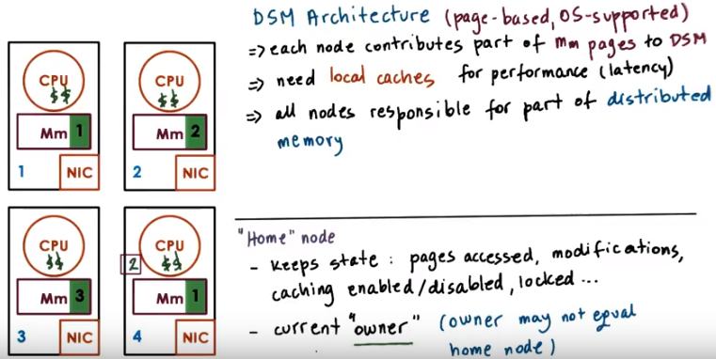
The home node will have to keep track of states, such as, what are the pages accessed, who is it accessed by, whether it's been modified. We may also choose to incorporate mechanisms to dynamical enable/disable caching for. For a similar motivation, like what we had in the sprite file system. What are the pages locked, that's another useful piece of information. All this information is used in enforcing the, shearing semantics that this particular DSM system will implement. One particular page is repeatedly and even exclusively accessed on a node that's not its home node. It would be too expensive to repeatedly contact the home node to perform any necessary state updates, so one mechanism that's useful in DSM systems is to separate the notion of home node, from the so-called owner. The owner is the node that currently owns the page that's, like the exclusive writer for instance. And that's the node that can control all of these state updates and can drive any consistency related operations. So this owner may be different from the home node, and in fact the owner may change, as, whoever is accessing this page migrates throughout the system or new processes, new threads require access to this particular page, they may become owners as well. The role of the home node for that page, in this case, that was node 2, is to keep track of who is the current owner of that page.

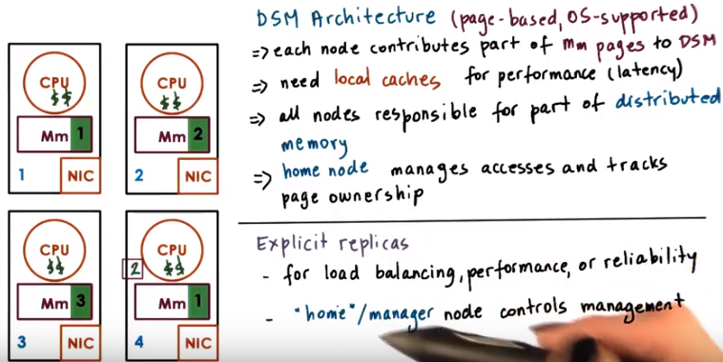
In addition to creating page copies via caching, in an on demand manner, page replicas can be explicitly created, for reasons such as load balancing, hot spot avoidance, or reliability reasons so that the page contents do not disappear if some note in the system fails. For instance, in data center environment that have lots of machines, where a certain distributed shared state is managed, it makes sense to triplicate such shared state on the original machine, on a nearby machine, for instance in the same rack, and then, on another remote machine, whether it's in another rack or even potentially in another data center. The consistency of these replicas is controlled either by the home node or by some designated management node.

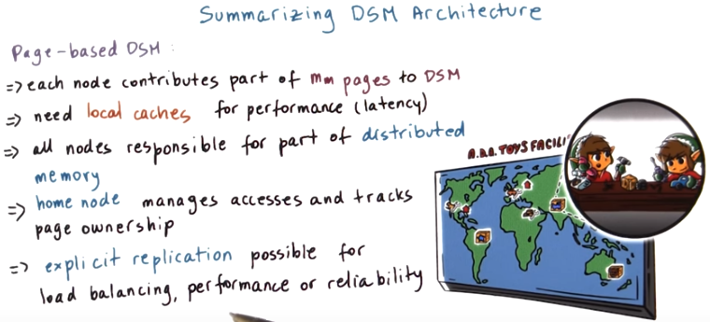
16. In summary, here's some of the key architectural features of distributed shared memory systems. Specifically we're talking about page based distributed shared memory systems. Every node contributes part of its main memory pages to the DSM layer. Local caches are maintained to improve performance by minimizing the latency of the access to story node modes. All nodes are responsible for some portion of the distributed memory and of its management. Specifically, the home node for a page manages the accesses to that page and also tracks who currently owns that page. Who has ownership rights. And finally, some explicit replication could be considered in order to assist with load balancing. In order to further improve performance and to address certain reliability concerns.

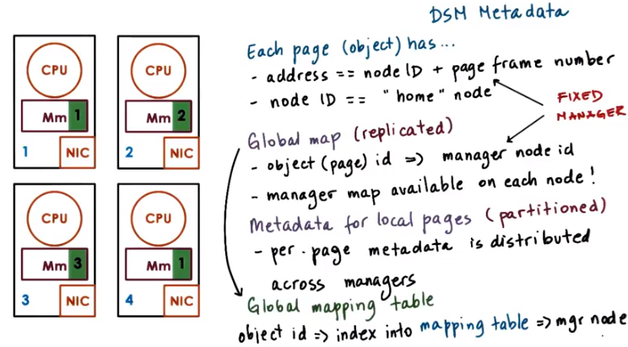
17. One important aspect of distributed shared memory systems is, how do we determine where a particular page is. In order to do this the DSM component has to maintain some metadata. First, let's see how is a page identified in this system in the first place. Well, the page has its address. And that may be some notion of the node identifier plus the page frame number locally at that node. And we said that the node identifier also identifies the home node of the system. Considering this address format then, we see that the address itself directly identifies what is the manager node, the home node. That knows everything about that particular page. Every single node in the system just by looking at the address of a particular page. Can uniquely determine what is the manager node for that page. So it's as if the manager information is available on every single node in the system. This could be captured via a global map that has to be replicated that will tell us how for a particular object we find the manager. What that means is that the information about the manager is available on every single node. So it's as if the information about the manager is available on every single node. Since whenever any of the nodes in the system wants to access a particular address, they just need to look at the node identifier. And we'll be able to get to the specific manager, the specific home node for that address. This information, that captures the translation from an identifier of an object, a page in this case, to the management node of that object, represents a global map. And this needs to be replicated. It needs to exist. This information needs to be available on every single one of the nodes. Once we get to a particular manager, that's the entity that will have the per-page, or per-object, metadata. That's necessary in order to perform this specific access to that page or to enforce its consistency. What this means is that in the DSM system, the metadata for individual objects or individual pages. It's partitioned across all of the home nodes. All of the management nodes in the system. But in order to quickly find where the manager for a particular data item is. It is necessary to maintain an additional data structure, a global map, that will be replicated on every single one of the nodes. That will in some way take an object identifier and map it to that manager. One final note, in the example that we discussed so far. We somehow implied that certain bits from the address are used to identify the node identifier. And that means that for every single page, there will be a fixed manager uniquely identified from that page identifier. If we want some additional flexibility, we can take that object identifier and then use it as an index into a mapping table. This mapping table is the one that will be used at every single node for the global map. And every entry in that mapping table will actually encode a manager node. So for a particular object or a particular page identifier, we will first index into that mapping table. Using some bytes from the object id or some hash function. That's applied on top of this object id. And then, the entry at the particular location at the mapping table will tell us what the manager node for that page is. What's nice about this approach is. If for any reason, we want to change who is the manager node for a particular object or of a particular page. Whether the original manager field or whether we need to rebalance the system or any other reason. We just need to update the mapping table. There is no need to consider making any kind of changes for the object identifier. The object can remain identified in the exact same way as it was before we chose to make a change into the manager nodes.

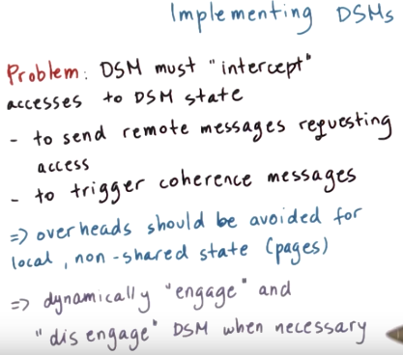

18. Now that we described the possible DSM architecture, I'd like to comment on its possible implementation. One thing to consider when implementing a distributed shared memory system is that the distributed shared memory layer has to intercept(攔截) every single access to that shared state. This is needed in order to detect whether the access is local or remote and then trigger remote messages requesting access, if that's necessary. Or to detect that somebody is performing an update operation to a locally controlled portion of the distributed shared memory and then to trigger any necessary coherence messages. These overheads should be avoided whenever we're trying to just access local, non-shared pages, or non-shared state. So what we would like to achieve is an implementation where it is possible to dynamically engage whether the distributed shared memory layer will be triggered, and will be intercepting any accesses to memory in order to determine what to do about them. Or disengage the distributed shared memory layer if we are performing access to pages which are really not shared and are just local pages accessed on a particular node.

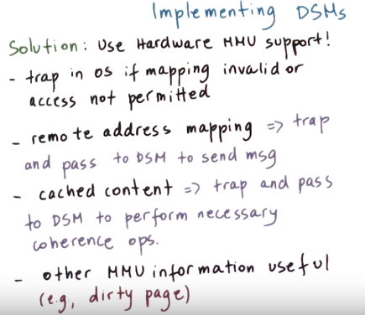

To achieve this, a DSM implementation can leverage the hardware support that's available at the memory management unit level. As we explained earlier, if the hardware MMU doesn't find the valid mapping for a particular virtual address in the page table, it will trap into the operating system. And similarly, the hardware will also cause a trap if it's detected that there is an attempt to modify a page that has been protected for a write operation, so a write protected page. We can leverage this mechanism to implement the DSM system. Whenever we need to perform an access to a remote memory, there will not be a valid mapping from the local virtual address to the remote physical address. The hardware will generate a trap in that case. And at that point, the operating system will detect what is the reason for that trap will pass that page information to the DSM layer, and the DSM layer will send the message. Similarly, whenever content is cached in a particular node, the DSM layer will ensure that that content is write protected. And that will cause a trap if anybody tries to modify that content that will turn control over to the operating system. The operating system can pass relevant information to the DSM module. And then that one will trigger all of the necessary coherence operations. When implementing a DSM system, it is also useful perhaps to leverage additional information that's also maintained by the existing memory management that the operating system and the underlying hardware provide. For instance, we can track information, like whether our page is dirty. We can track information whether our page has been accessed in the first place. And this can let us implement different coherence mechanisms and consistency policies. For an object-based distributed shared memory system that's implemented at the level of the programming language run time, the implementation can consider similar types of mechanisms that leverage the underlying operating systems services or as an alternative, everything can be done completely in software with support from the compilers, so tracking whatever particular object reference is remote or local. Or whether an object is going to be modified or not, we can make sure that we generate code that will perform those checks on every single object reference.

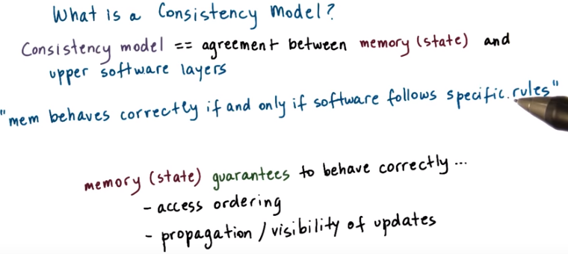

19. We said multiple times throughout this lecture that the exact details of how a distributed shared memory system should be designed or how the coherence mechanisms will be triggered depends on the exact Consistency Model. But before describing several Consistency Models, let's first explain what is a Consistency Model. Consistency models exist in the context of the implementations of applications or services that manage distributed state. The consistency model is a guarantee that the state changes will behave in a certain way, as long as the upper software layers follow a certain set of rules. For the memory to behave correctly what that means is that we're making some guarantees how our memory access is going to be ordered. For the memory to behave correctly, what that means is that the way that the operations will access memory will somehow be representative to how those operations were issued in the first place. And that, we will be able to make some guarantees that whenever somebody is trying to read the memory location that the value that they will see will be a value that's representative of what was written to that location recently. Now, what it means is that a consistency model guarantees that the memory will behave correctly, that the accesses will be correctly interleaved and the updates will be correctly propagated only if the software follows certain rules. That implies that the software needs to either use specific APIs when it performs an update or when it requests to perform an access, or that the software needs to set certain expectations, based on what this memory guarantee is. For instance that I'm just not going to enforce that updates the particular memory location are written in the exact same order as they were issued. If the software knows this particular information, then it is up to the programmer to use some additional operations, such as locking constructs or similar in order to get the desired behavior. This is not something that's specific to a distributed system. Even in a single CPU, when we have multiple threads that are trying to access a particular memory location, we know that there's no guarantee how those thread accesses will be ordered. And which particular update will be returned when, let's say, thread end tries to read a particular shared variable. If we want to achieve some guaranties that are stronger than that, the software will have to use locks, would have to use atomic operations, would have to use some counters. So, a consistency model, it specifies how the memory will behave and the upper layers of the software must understand that and set their expectations accordingly. At the same time, the memory layer may export certain API's, certain operations like the locks that we mentioned. And then, if the software uses those API's correctly, then perhaps the memory system can make even stronger guarantees.

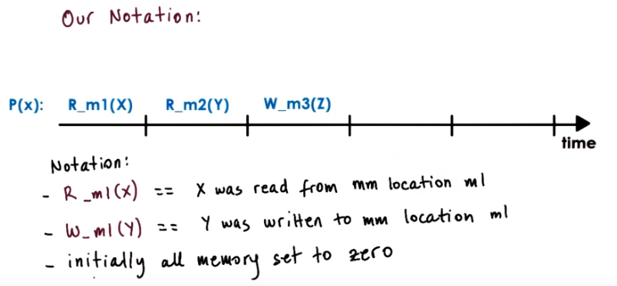
注意R_m1(x)中的x不是個變量, 而是個值(如354). R_m1(x)的意思不是 '讀變量x的值', 而是已經讀到了一個值, 此值即x(如354).

In the discussion of consistency models, we will use timeline diagrams which will look like this. Which will show when certain operations occur according to real time, based on some neutral external observer that sees everything instantaneously the minute those operations occur. Our notation for this is as follows: R_m1(x) means that this value x was read from a particular memory location m1. What this means here, is that at this particular point of time, the value x was read from memory location m1. And then at this later point in time, the value y was read from memory location m2. Similarly, W_m1(y) means that the value y was written to in this case, memory location m1. So, at this particular point in time, the value z was written to a memory location m3. We will also assume that initially at the start of this timeline diagrams all of the memory set to 0.

Consistency總結:

Strict consistency:
- Every single update has to be immediately visible and everywhere visible, and the ordering of these updates needs to be preserved.

Sequential consistency(記憶: 以下三點其實跟Causal consistency的三點是對應的, 即order, all, single)
- Memory updates made by different processors may be arbitrarily interleaved (即可以跟issue的不同).
- All processes will see the same order.
- Updates that are made by the same process always appear in order they were issued.

Causal consistency
- If updates are causally related, then will guarantee that those update operations will be correctly ordered.
- For writes that are not causally related or they're referred to in causal consistency as concurrent writes, there are no guarantees. they may perfectly legally appear in arbitrary orders on different processors. 即對於not causally reated或concurrent的, 不要求All processes will see the same order(跟sequential consistency不一樣. 例子見第27段quiz 2)
- Updates that are made by the same process always appear in order they were issued.

Weak consistency
- Writer processor sync後, 別人可見. Reader processor sync後, 它可見別人的.
- No guarantee what happens in between the two syncs(即上面的writer proc sync和reader proc sync). ie, orders can be observed arbitrarily.

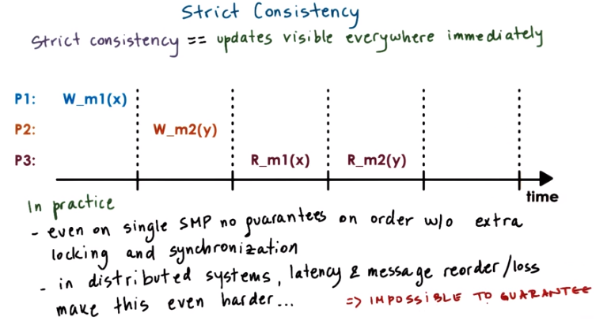
20. Theoretically for a perfect consistency model, we would like to achieve absolute ordering and immediate visibility of any state update and access, and we also want this to be in the exact same manner as those updates were performed in some real time. With this model, changes are instantaneous and immediately visible everywhere. So even if we had some read operations that were immediately performed over here to the locations m1 and m2, they would have still returned these values x and y. So in P3, regardless how far away (空間上) from P1 it is, P3 would always be able to instantaneously see that P1 performed this write operation to the memory location m1 and that it wrote x there. Furthermore, what's also really important about the strict consistency model is that it guarantees that every single node in the system will see all of the writes that have happened in the system in the exact same order. So, if we have the situation where P3 is maybe closer to P2 than P1, and these time intervals are really, really small, in reality it's possible that it took longer for this message from P1 to get to P3 so that P3 can see this x value. That's not allowed with strict consistency. 此話總結得好: Strict consistency, every single update has to be immediately visible and everywhere visible, and the ordering of these updates needs to be preserved. In practice, even in a single shared memory processor, there are no guarantees regarding the ordering of memory access operations from different cores, unless we use some additional locking and synchronization primatives. In distributed systems, the additional latency, any possibility for the messages to be lost or reordered make this not just harder, but also even impossible to guarantee. For that reason strict consistency remains a nice theoretical model, but in practice it is not something that's sustainable and other consistency models are used instead.

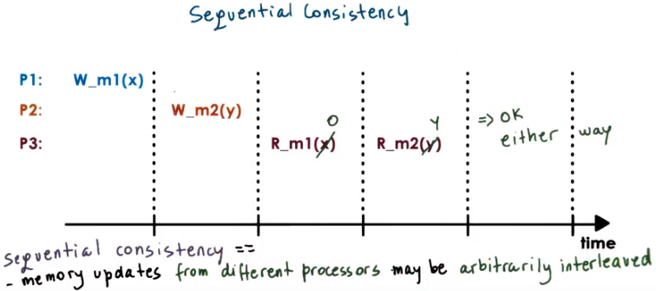
21. Given the strict consistency is next to impossible to achieve, the next best option with reasonable cost is sequential consistency. If you look at the example from the previous idiom, if x and y are completely unrelated, and P2 computed the value of y independently without any reference to the memory location m1. Then these two operations don't really have to strictly appear in this particular order. For instance, it is possible for P3 to observe, just like what we did in the previous case, that the value of m1 has become x. And then to see that the value of m2 has become y. But it is also perfectly reasonable for P3 at a particular point in time to access the value of m1 and to see that it's still zero. So it doesn't know that this right operation happened. However, at a subsequent moment when it tries to read the memory location m2, it sees that it has already been updated to y. This is the equivalent of what would happen in a regular shared memory system if we have multiple threads. And if we don't use any additional controls and your walking sequentializations and anything like that. When these two operations are issued, they will be applied in some way some order. But we don't necessarily have control which is the order that these operations will be applied in. So that's why we say that as long as the ordering that's observed is equivalent to some possible ordering of these operations. If they executed on a single shared memory system, then that would be considered a legal operation. According to this sequential consistency model. So, in summary, according to sequential consistency, the memory updates from different processors may be arbitrarily interleaved.

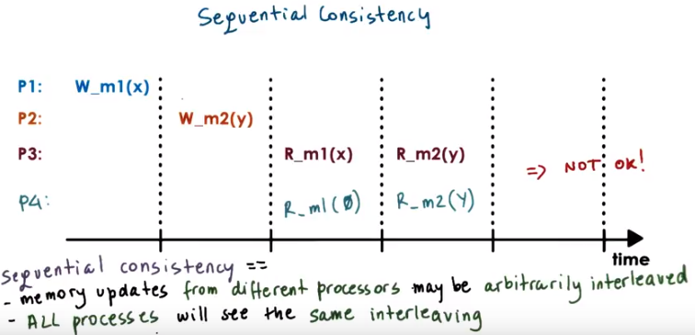
However, if, we let one process see one ordering of these updates. We have to make sure that all other processes see the exact same ordering of those updates. For instance, it is not okay to let process P3 see that the update to m1 with the value x. Appear before the update of m2 with the value y. And instead, at the same time to allow process 4 to think that the value of m1 was still zero. When the value of m2 was already updated to y. In this case, process P4 thinks that m2 has been updated before the memory location m1. It would be too hard to reason about what exactly will happen in a program execution, if every processor can see completely different ordering of some updates, and if we, the software or the programmer doesn't have an understand how and when are those updates reorder. What this means is that the sequential consistency, every single process will see the exact same interleaving. This interleaving may not correspond to the real way in which these operations were ordered. However, sequential consistency at least guarantees that every single process in the system will see the exact same sequential ordering of all of this.

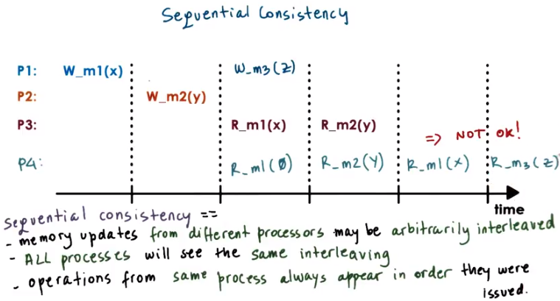

Recheck視頻後表示: 上圖中的NOT OK是上一個圖中留下來的, 此圖中可以無視, 即P4是OK的.

注意上圖中的operations from same process always appear in order they were issued.

And one constraint of the interleaving is that the updates that are made by the same process will not be arbitrarily interleaved. For instance, if P1 makes another update in the future. Then on any of the other processes, it will not be possible to first observe that the value z was written to the memory location, m3. And only then, find out that the value x was written to memory location m1. So for instance, what we see on P4. This will be correct under sequential consistency because the updates to m1 and m3 are observed here in the correct way. When it sees that the value of m3 was z, it already knew that the value of m1 had become x.

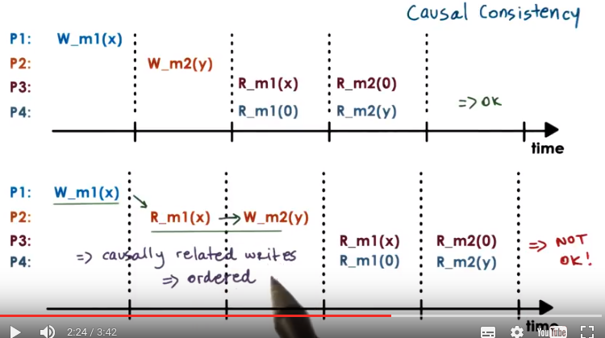
注意上圖是Causal(具有因果關係的), 而不是Casual(隨便的)

22. Forcing all processes to see the exact same order on all updates may be an overkill. For instance, P3 and P4 here may perform completely different in independent computations with the values m1 and m2. And furthermore, the update to m2 had nothing to do with the value of m1, they were also completely independent. However, if we take a look at the second example, before the value m2 was written, the value of the memory location m1 was read (by P2). This means that there is potentially some relationship (當然也有可能沒有relationship, 23段會討諭這點) between the memory location m2, this particular update to the memory location m2 and this update to the memory location m1. Given that this read operation that was performed at P2, just before this write. Return the value of this write operation that happened on processor one. There is clearly some flow of information, some potential dependence between these two updates that happened on two different processors. Based on this observation, clearly it is not okay for these two operations, this m2 update to y and the update of memory location m1 to x to be perceived in this different order. It would be very incorrect for somebody like P4 in this case to observe that the value of m2 was updated to y before the value of m1 was updated to x. P4 here thinks that m1 is still zero and then it finds out that m2 became y. But there is dependence between the fact that y was written to m2 and the fact that x was already written to m1. So clearly, this is not a reasonable execution. It will be very difficult for software to understand what is exactly happening with the memory if it cannot reason about dependencies like this. However, in this case, with such dependence (即W_m1(x)和W_m2(y)) did not exist. It will probably be okay for us to tolerate this kind of reordering. The consistency model that provides exactly this kind of behavior is called causal consistency. Causal consistency models guarantee that they will detect the possible causal relationship between updates. And if updates are causally related, then the memory will guarantee that those writes, those update operations will be correctly ordered.

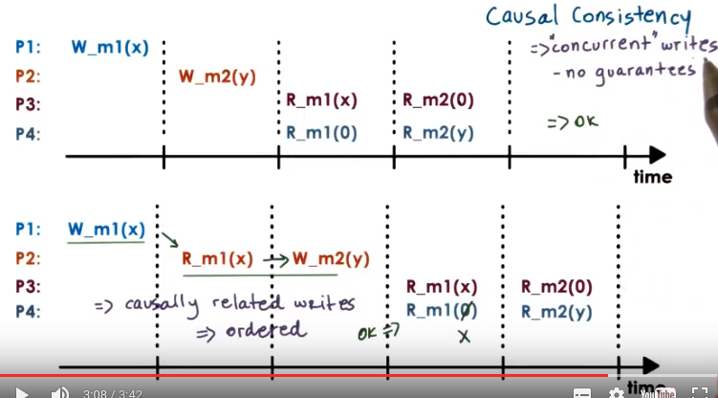
What that would mean is that in this situation where the two updates are in fact correctly ordered, we have to make sure that every processor observes that the update of x to the memory location m1 happened before the update of y to the memory location m2. So we have to make sure that on P4, this first read of the value of the memory location m1 returned an x. In this case, this execution will be causally consistent given this particular relationship between the updates. For writes that are not causally related or they're referred to in causal consistency as concurrent writes, there are no guarantees. Causal consistency doesn't guarantee anything about such updates and they may perfectly legally appear in arbitrary orders on different processors.

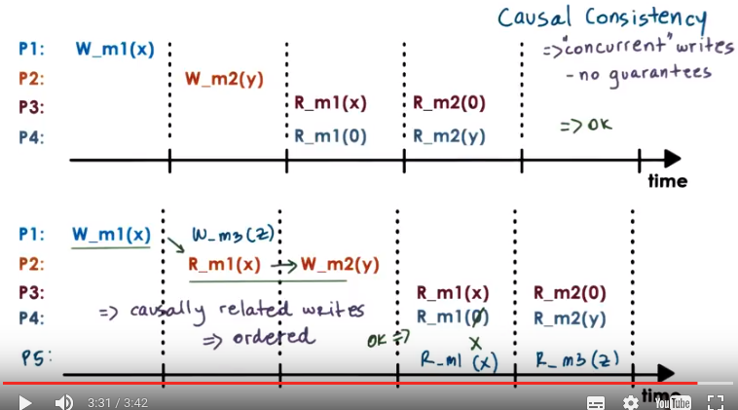
Just like before, causal consistency also makes sure that the writes that are performed on the same processor will be visible in the exact same order on other processors (意思就是跟sequential consistency的有一點要求一樣: Operations from same process always appear in order they were issued). Again, it would be too much of a challenge to understand how to really reason about a system if the updates from a single processor can be arbitrarily reordered.

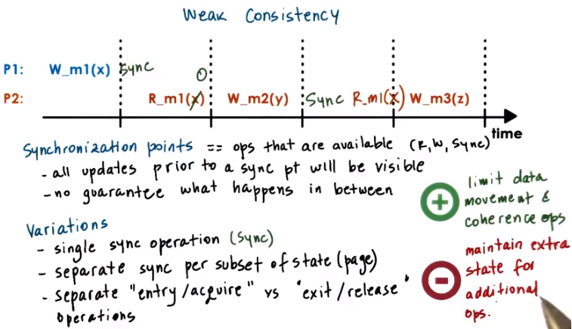

23. In the consistency models we discussed so far, the memory was accessed via read and write operations only. In the weak consistency models, it's possible to have something beyond just read and write operations when memory's accessed. In the models we've described so far, the underlying memory managers, or state managers in general, had to determine or infer what are important updates and then how to order and propagate the information regarding those updates. For instance, there's no way for the distributed memory managers to understand whether or not indeed the value of y was somehow computed based on this value x that was read from m1. So it's perfectly possible that p2 really just completely randomly came up with this value y that was written in m2, and that had nothing to do with this fact that it previously read the value of x from location m1. So it saw this particular update. However, with the causal consistency model, it will be forced that every process, every processor in the system has to observe that the value of the memory location m1 has been updated to x before the value of the memory location was updated to y. However, for instance, in the same process, p2, maybe at a later time there is another update that's happening to memory location m3, and the value z is written there. And perhaps this particular value, z, was directly computed, based on the value that was read from memory location 1 (R_m1(x)). So there maybe is a dependence between this particular write (W_m3(z)) and the value that was read here (R_m1(x)), but not between these two (W_m2(y)和R_m1(x)). How can a memory system distinguish these? To do this, the memory system introduces synchronization points. The synchronization points are operations that the underlying memory system makes available to the upper layers of the software. So, in addition to being able to read and write a memory location, you'll also be able to tell the distributed shared memory sync. What a synchronization point does, it makes sure that all of the updates that have happened prior to sync, the synchronization point will become visible at other processors. And also, synchronization point makes sure that all of the updates that have happened on other processors will become visible subsequently at this particular processor in the future. If p1 performs a synchronization operation at this particular point after this write was performed, that doesn't guarantee that p2 will see that particular update at this moment. Although this read operation (by P2) is happening according to some real time, some external observer, at a later point in time than the synchronization point in the preceding write, p2 has not made an attempt to synchronize with the distributed shared memory. So p2 has no guarantees that it will see the updates performed by others. So this synchronization point, it has to be called both by the process that's performing the updates, and also by the processes that want to see, and want to see the guarantee that they will see updates. However, once the synchronization operation is performed in p2, afterwards, p2 will be guaranteed that it will see all of the previous updates that have happened to any memory location in the system. So if we perform a read operation of the memory location m1 at this point in time, after the synchronization, we're guaranteed that p2 will see this update. In this case, in this model, we use a single synchronization operation for all of the variables in the system, for the entire shared memory. It is possible to have solutions where different synchronization operations are associated with some subset of the state. For instance, with a granularity of individual pages. It is also possible to separate the steps when a particular process requires that all of the updates performed by other processors are visible to it (視頻中指到P2的那個sync的). We call that the entry point, or the point when we are acquiring the updates made by others. For instance, at this particular synchronization point we can perform an entry operation and synchronize with all the updates that were performed on others, in this case on p1. And then we can have a separate synchronization primitive, that's the exit point (視頻中指到P1的那個sync的) or this is the point where we release to all other processes or processors the fact that we have performed certain updates. So for instance, at this synchronization point, only the updates made by p1 will be forced to other processes. The idea with these finer grained operations or these mechanisms to really directly control what kinds of messages will be sent by the underlying state management system, by the DSM layer at a particular point of time, is to make sure that the system controls the amount of overheads that are imposed by the DSM layer. The idea is to limit the required data movement, the required messages and coherence separations, that will be exchanged among the nodes in the system. But the downside of this is that the distributed shared memory layer will have to maintain some additional state to keep track of exactly what are all the different operations that it needs to support and how it needs to behave when it sees a particular type of request. In summary, all of these models that, in addition to just pure read and write operations, introduce some types of synchronization primitives are referred to as weak consistency models and they allow us to control the overheads of the system from one aspect. However, they introduce some additional overheads that are necessary in order to support that the added operations.

24. For the next few quizzes, I'll ask questions that are all related to the consistency models we just looked at. For each quiz I will show you a timeline, and I will ask you whether if that particular execution is consistent according to some consistency model or not. Here is the first quiz. Consider the following sequence of operations. I'm showing two processes P1 and P2 and according to some real time they're performing certain operations. The question to you is is this particular execution of these two processes sequentially consistent? The possible answers are yes or no.

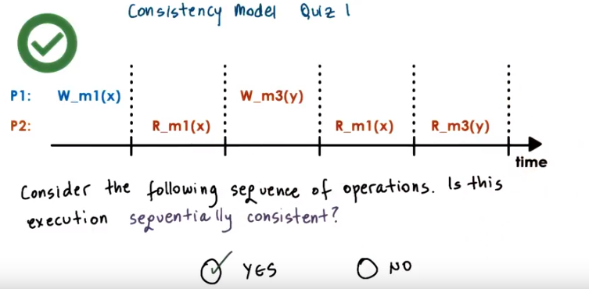

25. This is a somewhat trivial example so the answer yes. This is a sequentially consistent execution. Any of the updates in the system are all performed from processor one. We know that sequential consistency requires that all of the updates from a single processor, that they be visible in the same order. And if we take a look at P2, yes indeed. The fact that the memory location m3 was updated to value y only becomes visible after we have seen that on P2 that the value of m1 has become x. If we had a situation where these reads here to m1 (那兩個R_m1(x)) were still returning zero. So, this write was not visible however, this read from m3 already returned y so this write became visible that would've been the problem (第21段sequential consistency: operations from same process always appear in order they were issued), but that's not the case in this scenario. So this is the correct answer.

26. Here is a second quiz. Again, there are a number of processes, P1 through P4, and their execution over time. And the question is, considering the following sequence of operations, is this execution sequentially consistent? And then what if the question was, is it causally consistent? For each of the models, sequentially consistent or causally consistent, answer the question with yes or no.

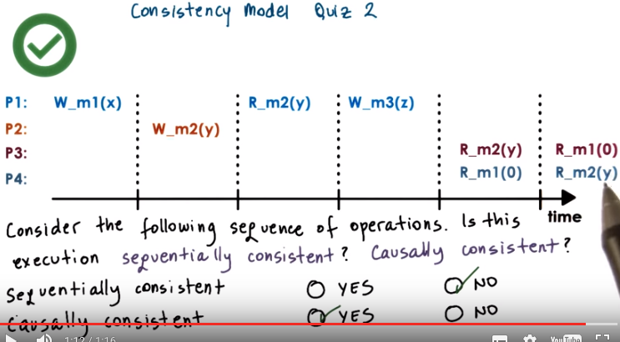
27. If we look at the execution here, we see that P3 and P4 observe the updates to the memory allocations M1 and M2 in reverse way. We take a look at what's happening here, we see that M1 and M2 are not causally related. So regarding causal consistency, this is okay. This execution is correct with respect to causal consistency. However, regarding sequential consistency, we said that that all the processors in the system must observe the same order of the events that are occurring on some other processors. So, in this case, this would not be legal as far as sequential consistency is concerned. So, the correct answers for these questions is this is not a valid execution for sequential consistency, but it is with respect to causal consistency (前面22段已經說了: For writes that are not causally related or they're referred to in causal consistency as concurrent writes, there are no guarantees. They may perfectly legally appear in arbitrary orders on different processors. ). Meaning that, if we're running an application on top of a memory model, that we know [INAUDIBLE] causal consistency, if we observe this kind of behavior, this is perfectly legal. We cannot complain to anyone. However, if we observe this kind of behavior when running an application on top of a supposedly sequentially consistent system, we have the rights to complain, this is not correct. Somebody has made a mistake with their implementation of this system.

28. Now let's look at the quiz number three in this sequence. We have a very similar set of executions and processors P1 and P2, and slightly different focus on what's happening on P3 and P4. The question is the same. Considering the following sequence of operations, is this execution sequentially consistent? You need to provide your answer yes or no. And also, is this execution causally consistent? Again, you need to provide your answer yes or no.

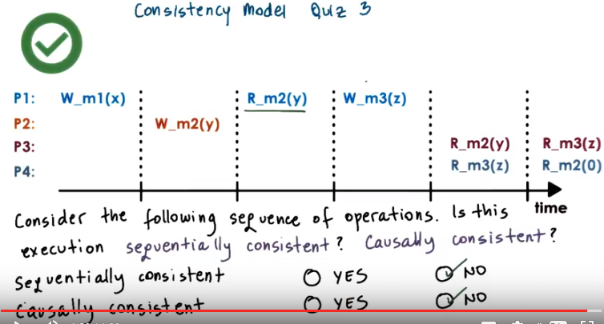
上圖中, m2先被P2設為y, m3再被P1設為z, 且 'm2被設為y' 是 'm3被設為z' 的原因. P4先看到m3為z, 然後看到m2為0, 即P4認為是 'm3先被設為z, m2再被設為y', 故不是causally consistent. 而P3認為是 'm2先被設為y, m3再被設為z'. P3和P4順序相反, 做不是sequentially consistent.

29. If you take a look at what's happening on P3 and P4 in this case, we see that now P3 and P4 are observing reverse order of how they saw the updates to m3 and m2. As far as P3 is concerned, P3 observed that this update to m2 happened, and it also observed that this update to m3 happened. As far as P4 is concerned it observed this update of z to the memory location m3. But it still has not seen that P2 updated the memory location m2 with the value of y. It thinks that still the memory location m2 holds value zero. So P4 thinks that this write occured before this write from P2, and then P3 thinks the other way around. This is clearly illegal as far as sequential consistency is concerned. Now if we take a look at these two updates we see that on P1 before the value of the memory location m3 was updated to z, P1 read the value of the memory location m2 and it saw that that value was y. So it saw the effects of this particular update. What that means is that these operations are potentially causally related, and therefore every processor in the system has to observe that this particular update happened after the update to m2 given the causal relationship between the two. Therefore the answer is no for both of these questions.

30. Here's another quiz on the consistency model. Now we are looking at a weakly consistency model, so we see that in addition to writes and reads, the processor performs synchronization operations. And the question that I'm asking you is, given this sequence of operations, is this execution weakly consistent? Again, pick either yes or no.

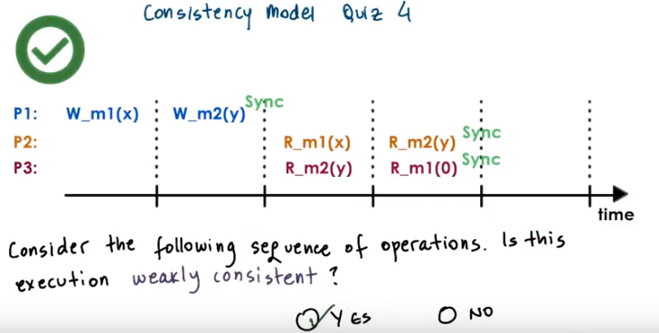
31. The answer to this question is yes. Although P2 and P3 observe these operations in arbitrary way, neither one of them synchronized and forced the memory, the underlying distributed shared memory, to make any kind of guarantees regarding the updates that it observes. Weak consistency will not make any guarantees regarding the ordering unless explicit synchronization operations are used.

32. And for the final quiz in this sequence, if you ignore this sync operations that we had in the fourth quiz, is the rest of the execution causally consistent? Yes or no?

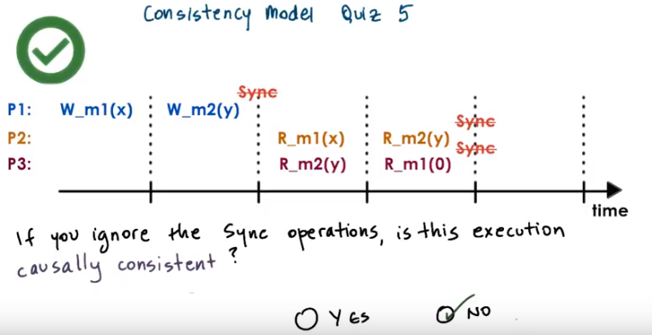

33. The answer to this question is no. It is not causally consistent because causal consistency does not permit that the writes from a single processor are arbitrarily reordered. (前面22段已經說了: Just like before, causal consistency also makes sure that the writes that are performed on the same processor will be visible in the exact same order on other processors.意思就是跟sequential consistency的有一點要求一樣: Operations from same process always appear in order they were issued.)

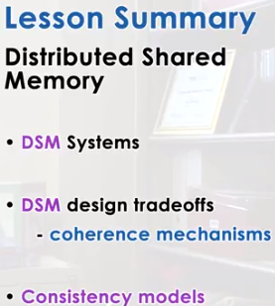

34. In this lesson we talked about distributed shared memory systems, and about the mechanisms they use in order to manage that distributed state. We talked about coherence mechanisms, we talked about consistency models that are meaningful in those environments. As a final reminder, note again that all of what we talked about was in the context of memory management. These types of methods apply to other applications that are responsible for managing distributed and shared state.

35. As the final quiz, please tell us what you learned in this lesson. Also, we would love to hear your feedback on how we might improve this lesson in the future.

